Enhancing Company Registration Security
Using Real-Time Camera-Based Age and
Gender Verification
Assignment: Use and Demonstration of Two DevOps Tools
Project Title:
Enhancing Company Registration Security Using Real-Time Camera-Based Age and Gender
Verification
Client:
SenimSolution LLP
Team Members:
- Ishwari Mahajan- 202301040173
- Omkar Londhe - 202301040027
- Sneha Nannaware- 202301040267
- Yashraj Jagtap- 202301040092
- Om Thorat - 202301040155
- Sumit Khetre - 202401040017
Objective:
Tobuildasecure, AI-based verification system that enhances security during company registration by verifying age and gender through real-time camera analysis.
DevOps Tools Utilized
- GitHub – Version Control & Collaborative Development
Purpose:
GitHub was used to manage source code, ensure collaborative development, and maintain version control across the project lifecycle.
Implementation Details:
  - Repository Management: Centralized GitHub repository to store frontend, backend, and AI model code.
•
Branching Strategy: Separate branches created for modules like camera integration, AI model training, API development, and UI enhancements.
•
Pull Requests (PRs): Mandatory code reviews before merging to maintain quality and consistency.
•
Issue Tracking: Used GitHub Issues to track bugs, enhancement requests, and
  - development progress.
Commit History: Clear, descriptive commit messages were maintained for better traceability.
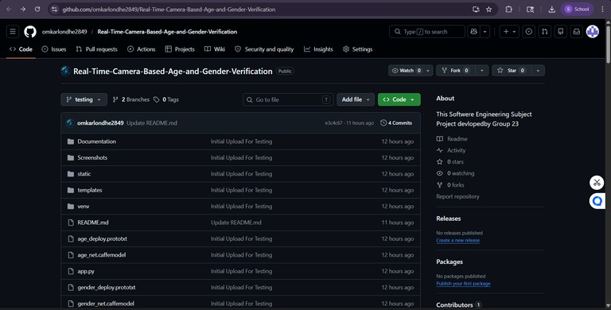
- Docker – Containerization for Consistent Deployment
Purpose:
Docker was used to containerize the AI verification backend, frontend interface, and database to ensure consistent environments across development, testing, and deployment.
Implementation Details:
  - Dockerfile: Defined environment specifications for Python backend (Flask server) and AI model.
•
Docker Compose: Managed multi-container setup including Flask server, MySQL database, and React frontend.
•
Containerization: Each service (backend, frontend, database) was run in a separate container for modularity.
•
Docker Desktop: Used for local container orchestration and monitoring.
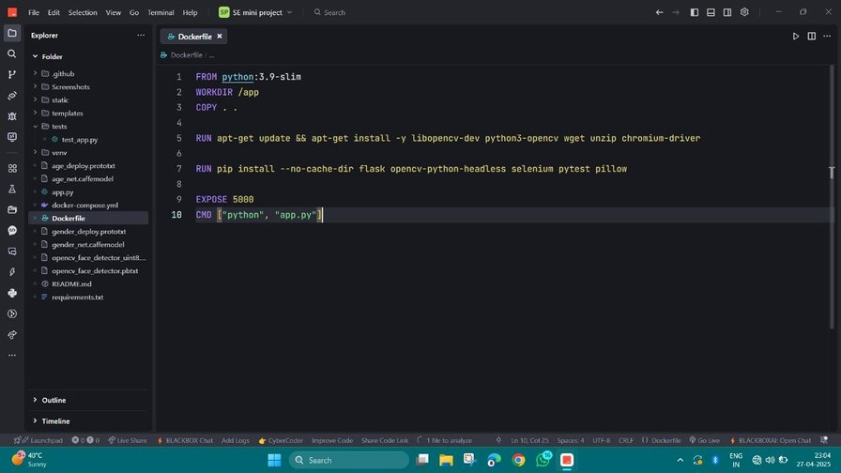

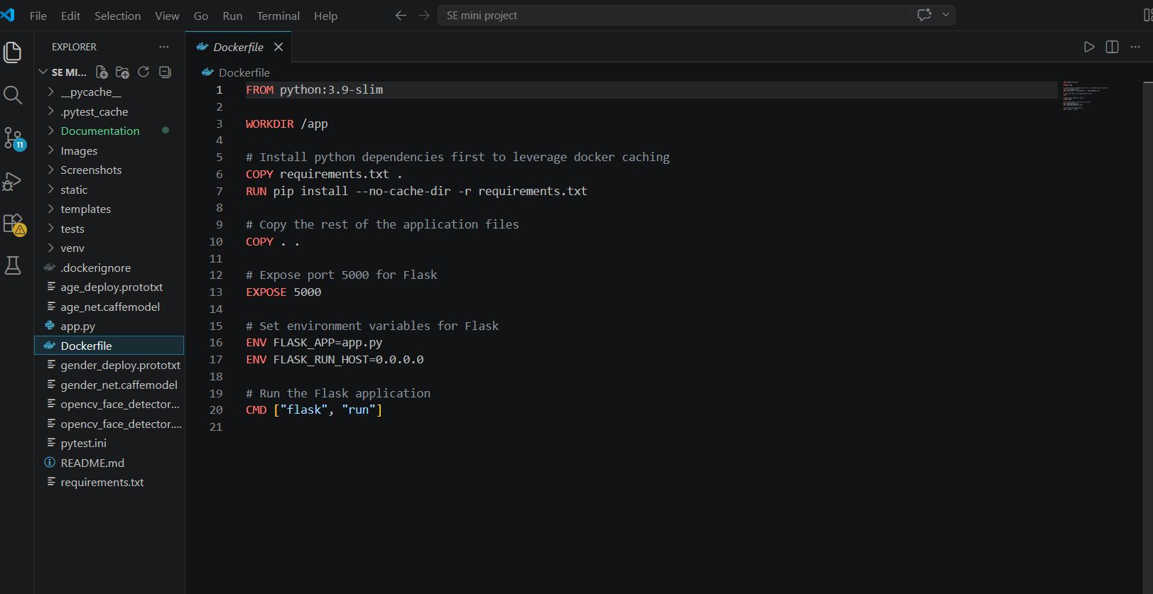
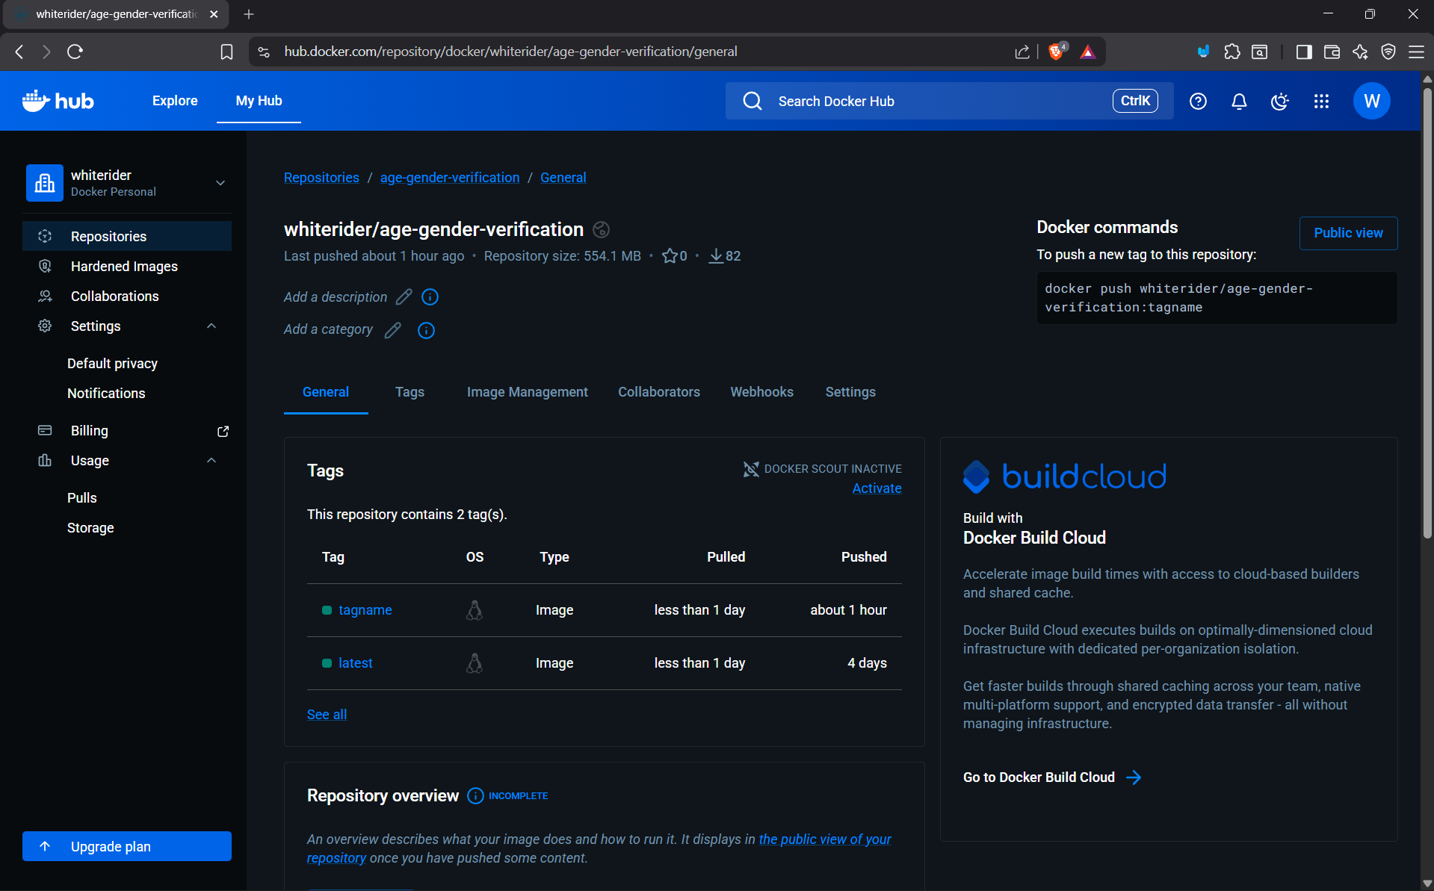

- Selenium – Automated Testing for Quality Assurance
Purpose:
Selenium was utilized for automating UI testing to ensure the correctness of user flows such as registration, camera verification, and login processes.
Implementation Details:
  - Test Automation: Automated key workflows like user registration, image capture validation, and admin dashboard access.
  - Cross-Browser Testing: Verified system functionality across Chrome and Firefox browsers.
  - Error Detection: Detected issues such as UI misalignment, button malfunction, or delayed responses early in the development stage.
  - Regression Testing: Automated tests were rerun after every major code update to ensure no functionality was broken.
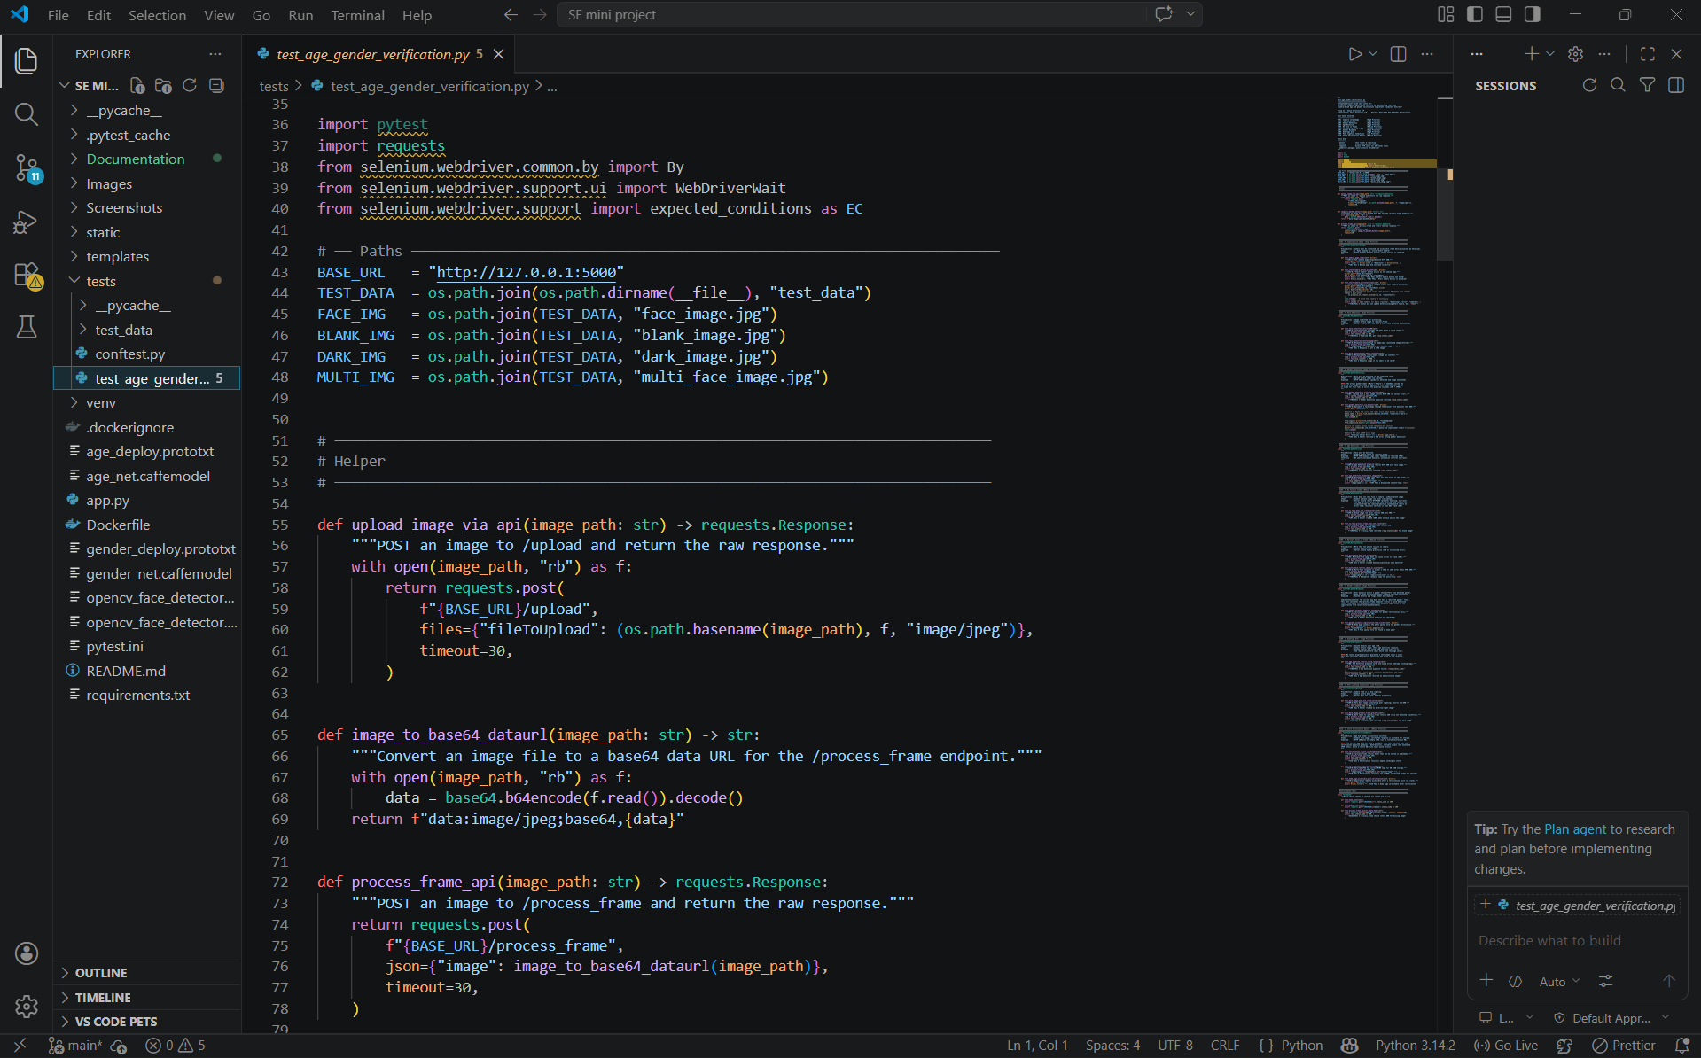
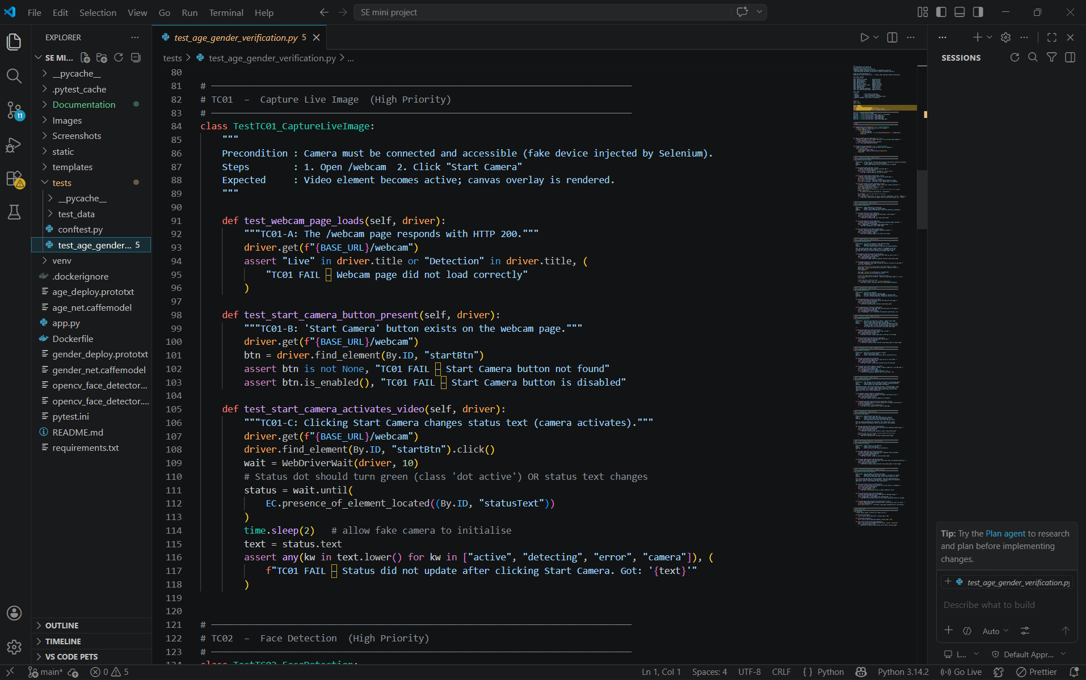

Output :
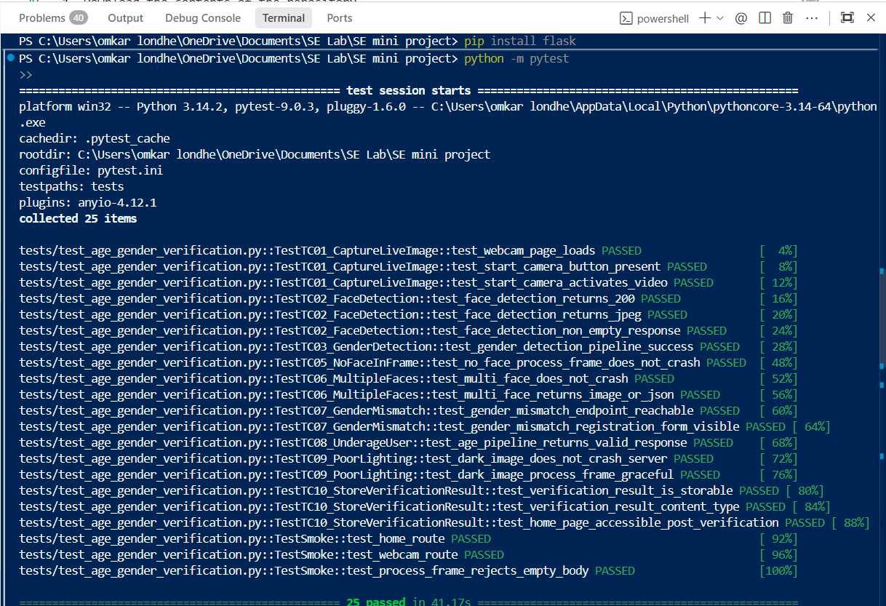

Software Requirements Specification (SRS)
Reference Document: Enhancing Company Registration Security – SRS.pdf Highlights:
  - Functional Requirements: Real-time camera capture, AI-based age and gender prediction, registration portal integration.
•
Non-Functional Requirements: High accuracy, fast verification response, secure data handling, compliance with GDPR.
•
User Roles: Applicants, Business Administrators, System Administrators, Compliance Officers.
•
System Architecture: Modular design integrating camera hardware, AI verification, backend server, and company portal via APIs. Outcomes and Benefits GitHub:
- Ensured streamlined collaborative development with version control.
•
Improved code quality through structured branching and peer-reviewed pull requests. Docker:
- Achieved consistent deployment environments across all team members' machines.
- Simplified the deployment process, minimizing environment mismatch errors.
Conclusion
The integration of GitHub and Docker into our development workflow greatly improved our ability to collaborate, manage versions, and maintain consistent deployment environments for the project. Leveraging these DevOps practices helped us achieve a more organized, efficient, and scalable development process.

